Exam 1, BIOL 4240
Due in class 03/05/19
Please type all your answers and make sure you do your work on your own and that your answer sheet has your name as well. Please staple everything before you hand it in. MAKE SURE YOU ANSWER ALL PARTS OF THE QUESTIONS
- (25 Points total) Retinoic Acid (RA) is a molecule derived from Vitmain A. It is not a protein or encoded by a gene. Retinoic Acid binds to a nuclear receptor and then changes the transcription of target genes by binding to a promoter sequence, the RARE, present in all target promoters. See below:
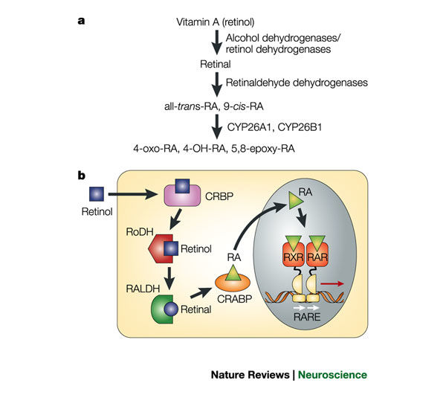
When gastrula stage frog embryos are treated with high levels of RA, they typically show defects and deficits in anterior nervous system structures.
- What can you conclude is the function of RA in nervous system development from the above results? (5 points)
- How would you ask whether endogenous RA is required for posterior nervous system development? Suggest a plausible experiment based on the above information (remember that RA is not a protein.) Describe your positive controls and negative controls and the purpose of those controls. Describe the most likely outcomes of your experiment. (20 points)

- (25 Points total) Morphogens in development are signaling molecules that emanate from a restricted region of a tissue and spread away from their source to form a concentration gradient. They act on cells directly to induce distinct cellular responses, such as inducing neural plate formation. In a recent transcriptome screen, a newly discovered gene, called Not Really a Gene (NRG) was found to be expressed just prior to neural plate induction in chicks. In situ hybridization confirmed that the NRG gene is turned on in the underlying mesoderm at that time.
  - From the data above, can you conclude whether NRG is really a morphogen? Why or why not? (5 points)
  - Your professor tells you that he needs some preliminary data because he is submitting a grant on NRG and early morphogen activity. Describe at least two experiments you can run that will give definitive evidence that support NRG as a morphogen in early neural induction. In other words, what are some experiments that show NRG acts in a concentration dependent manner and act directly on cells to induce a neural fate? (20 points)

- (25 points total) In classic “transplant” experiments, the future neural plate (nervous system) of a frog embryo was moved from its usual dorsal position to the ventral region of a host embryo. The host and donor embryos were either at the early gastrula or late gastrula stage when the transplant was performed and all were examined when embryos reached mid neurula stage

When the future neural plate of an early gastrula donor is transplanted, it develops as non-neural tissue (epidermis) on the ventral side of the host. However, when the future neural plate of a late gastrula donor is transplanted, it develops as a second neural plate on the ventral side of the host, as diagrammed below. 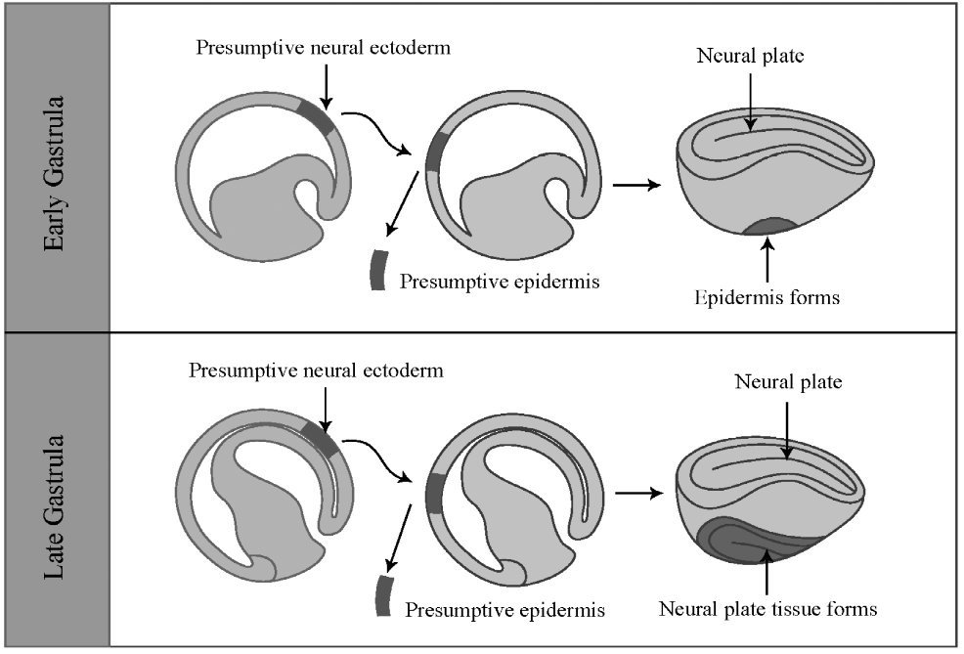
  - In order to perform this experiment, a researcher would need to know which piece of tissue is going to give rise to the neural plate. How would you determine this? (5 points)
  - What are two hypotheses that could explain the above results? (5 points)
  - Eschaton is expressed in late gastrula stage neural plate. Describe an experiment to test the correlation of Eschaton expression with the ability to form a neural plate (note: I did not say induce neural plate formation). (5 points)
  - Describe a result that is consistent with this correlation and a result that would be inconsistent with this correlation. (5 points)
  - You suspect that Eschaton is required for neural plate formation. To test this, you try a loss of function approach. Describe this experiment and the main result that would be consistent with your hypothesis. (5 points)

- (25 points total) A novel inhibitor of Notch signaling was found recently called Botch (Blocker of Notch). Downregulation of Botch leads to more Pax6+ radial glia in the ventricular zone and overexpression of Botch leads to greater number of Tbr1+ cells in the cortical plate during cortical neurogenesis
  - Many proneural proteins could give the same results as those above. Design an experiment that demonstrated that Botch directly inhibits the Notch signaling pathway. (10 Points)
  - Some studies have shown that Notch signaling promotes S phase entry in addition to promoting self-renewal. If Botch inhibits Notch, formulate a hypothesis as to how Botch expression could affect cell cycle entry. Design an experiment to test that hypothesis and clearly explain your results. (15 points)

